REGISTRATION

Name________________________
Street________________________
City, State, Zip_________________
Phone________________________
Email_________________________

DIETARY NEEDS
□ No restrictions □ Vegetarian
□ Other___________________

PAYMENT
Please send deposit of 50% with this registration form.
Final payment of 50% due Nov 1.

CONTACT INFO
Please send payment to:
Naby Bangoura
2426 Grant St. #8
Berkeley, CA 94703
Cell: (510) 290-4787
Email: yarienaby@yahoo.com
Family in Conakry, Guinea:
011-224-664-98-84-43

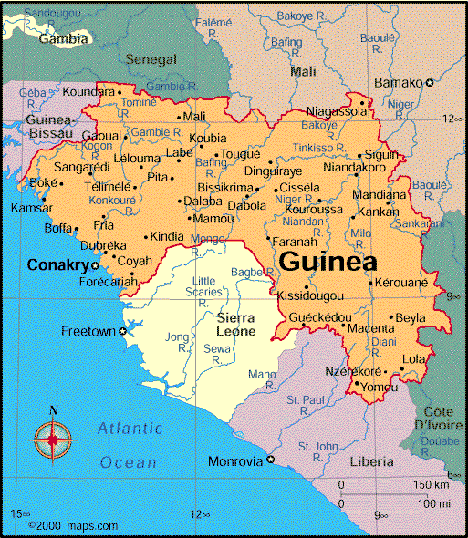

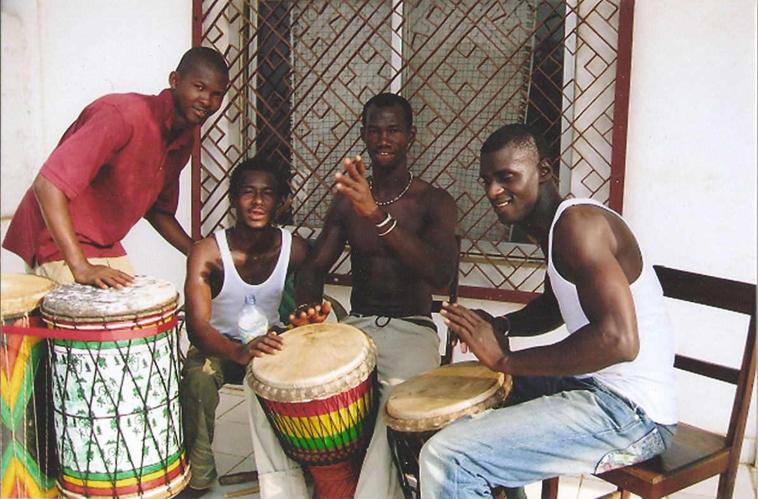

Na mun ye biassi

“Cultural trip” Dance and Drum Workshop in Guinea,

West Africa

Dec 29, 2014-

Jan 18, 2015
with
NABY BANGOURA
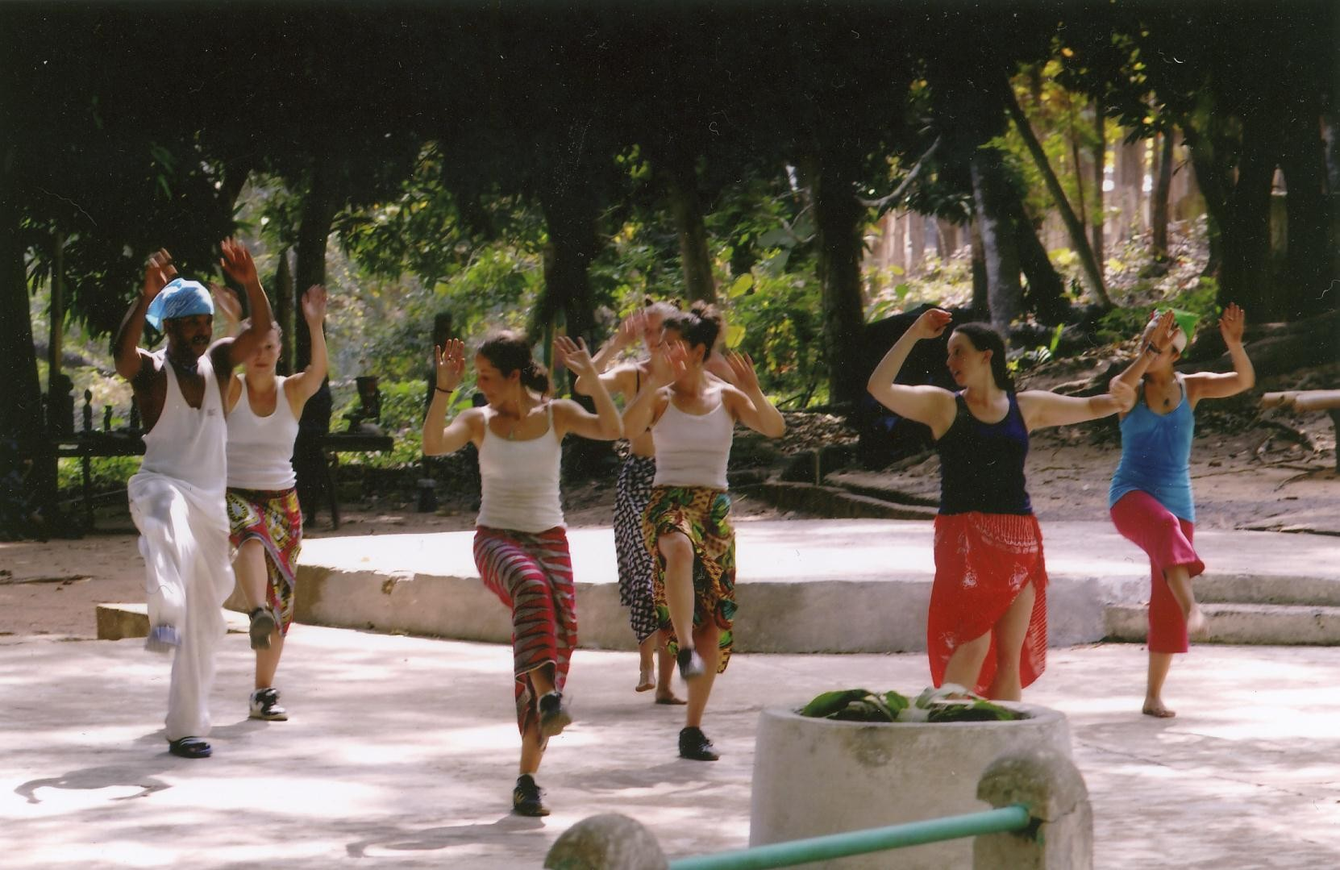

DANCE AND DRUM WORKSHOP
Participants will travel with Naby Bangoura to the city of Conakry and his home village of Kindia. We will learn the dances, rhythms, and songs of peoples across Guinea, from the coastal region to the forest region. Naby and others will share the history and stories of the rhythms and cultural traditions. We will visit dance companies such as Ballet Djoliba and Les Merveilles de Guinee. Monday-Friday there will be two dance classes scheduled each day with Naby and local artists. Saturday morning we will review the choreography from the week. We will enjoy one trip to the waterfall in Kindia, one trip to the island of Roume, one trip to the large market in Conarkry, one trip to see the National Ballet, and one trip to a dundumba party. Drum students will be able to study with guest drum teachers and perform with local drummers to accompany dance classes. If you are customizing workshop dates, check with Naby before making travel arrangements to confirm the travel dates to Kindia and Roume. Naby is hosting a big dundunba party on Jan 17th. Choreography will build throughout the workshop. All levels of dancers and drummers welcome, no experience necessary. You can view video from Naby’s 2006 trip at: http://nabybangoura.com/videos
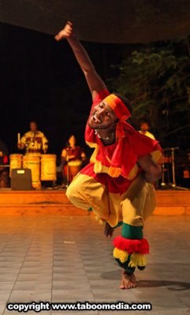

ABOUT NABY BANGOURA
As a student in Conakry, Naby studied the history of the Guinean culture. After school, he danced with Les Mervielles de Guinee, a professional dance company directed by Mohamed Kemoko Sano. He went on tour with Les Mervielles to Guinea, Mali, Burkina Faso, and the United States. Known for his energetic and fluid style, master dance teacher Naby Bangoura has been performing and teaching West African Dance-Guinea Style in dance studios and workshops all over the United States.

HEALTH/ VACCINATIONS
Check with the CDC (http://wwwn.cdc.gov/travel/destinationGuinea.aspx) for recommended health and immunization information. SF DPH Travel Immunization Clinic:
http://www.sfcdcp.org/travelers.html

LODGING AND FOOD
Naby’s family will provide home cooked meals and lodging in Conakry. Breakfast includes coffee, eggs, and fresh fruit. Lunch and dinner include home cooked rice with African sauce.

PASSPORT AND VISA
American citizens need a US Passport
and visa. For a visa, you will need application, passport, 3 photos, airline ticket, proof of yellow fever immunization and $100. For info, contact the Embassy of the Republic of Guinea in New York (212-687-8115 ) or Washington D.C. (202-986-4300.) Contact Naby for assistance.

COST
One week: $550. Two weeks: $1100
Complete workshop (3 weeks): $1650
Cost includes drum and dance
classes, food and lodging,
and ground transportation for specific workshop trips. Airfare is not included.

AIRLINES TO CONAKRY
Air France (SF-Paris-Conakry):
www.airfrance.us
Brussels Airlines: brusselsairlines.com
Delta: www.delta.com
Royal Air Maroc (from New York): royalairmaroc.com

